1 channel rf delay relay
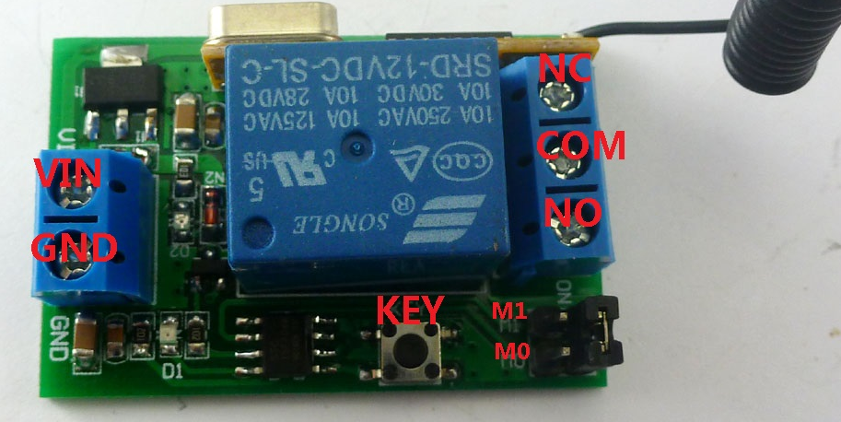
Features:
1 Operating voltage: DC 9-13V (recommended DC 12V);5V version can be customized
2 Operating Current: relays close, about 9MA; relay open,about 42MA;
3 Operating frequency: 433.92M; 315M version can be customized
4 Receiver sensitivity : -108dBm
5 Decode : learning code, can be adapted EV1527 / PT2262 and compatible remote control, you can store up to 32 remote control
6 Work mode : Non-locking (Momentary is defult),Self-locking (Toggle),Inter-locking (Latch)， Delay; 1-5000 seconds adjustable delay time, minimum step 0.1 seconds
7 Size(Including housing）50*35*22mm
8 Weight(including housing) 30g
9 Relay Maximum load(Recommended<5A):10A/250VAC,10A/125VAC,10A/30VDC, 10A/28VDC ,10A/12VDC

Work mode
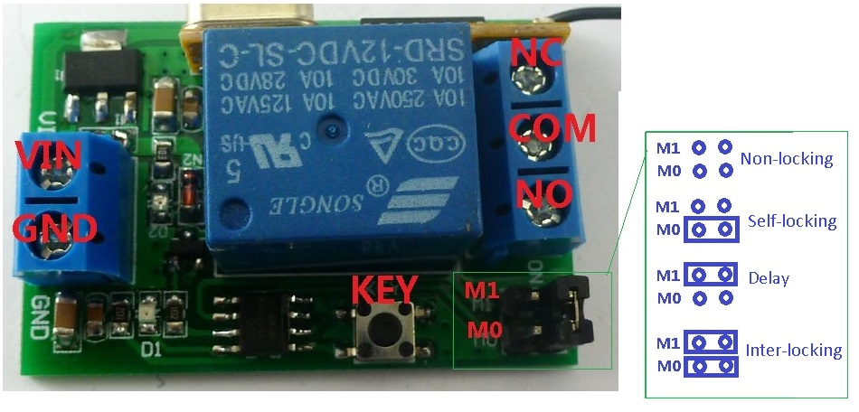
NO : Relay normally open contact
COM : Relay common contact
NC : Relay normally closed contact
Open : NO connection COM, NC disconnect COM
Close : NO disconnect COM, NC connection COM
Momentary : Press the Transmitter button , the receiver relay is Open, release button; the relay is Close;
Toggle : Press transmitter button for 1 time , the receiver relay is Open, press button again, the relay is Close;
Latched : Press transmitter button A, the receiver relay is Open
Press transmitter button B, the receiver relay is Close.
Delay : Press the Transmitter button, the receiver relay Open,After a set time delay, the receiver relay is Close;
If during the delay, press the button of Transmitter, delay start again; if the delay period, press and hold the button of Transmitter 3-4 seconds, the receiver controller stops the delay, the relay Close

Adapter remote control (learning remote control):
Under normal operating mode, LED will be lit, when receives a valid remote control (EV1527 / PT2262) button values, LED flashes

Clean code: press the key and held down, LED off, LED will light about 8 seconds later, clean code is completed (Note: After performing clean code previously stored remote control value does not exist)

Step 1 (into the learning mode): Press the key (about 1 second), LED off;
Step 2 (adapter button): Then press the utton on the remote control, LED flashes four times on, then learning the button value
Note:
Only the Non-locking (Momentary is defult),Self-locking (Toggle),Inter-locking (Latch) mode to a "clear code" and " learning " action
In the "delay" mode can only set the delay time

Delay setting:
Step 1, the mode is set to "delay" mode (jumper cap on the M1 into two rows of pins)
Step 2, press the key until the LED is off
Step 3. Click the key again, LED flashes
Step 4. Click the key again after a period of time, LED light
LED blinking time is the delay time.

Video Links : https://1drv.ms/v/s!AnlWQ-iun_89-lyxG0gNgIf7puE2

