​

Product Name: 5V/2.1A Out UPS mobile power Diy Board Charger & Step-up DC DC Converter Module for 3.7V 18650 lithium battery

Packing list:

1 PCS DD04CVSB_5V 10W charge and Discharger boost modules output 5V

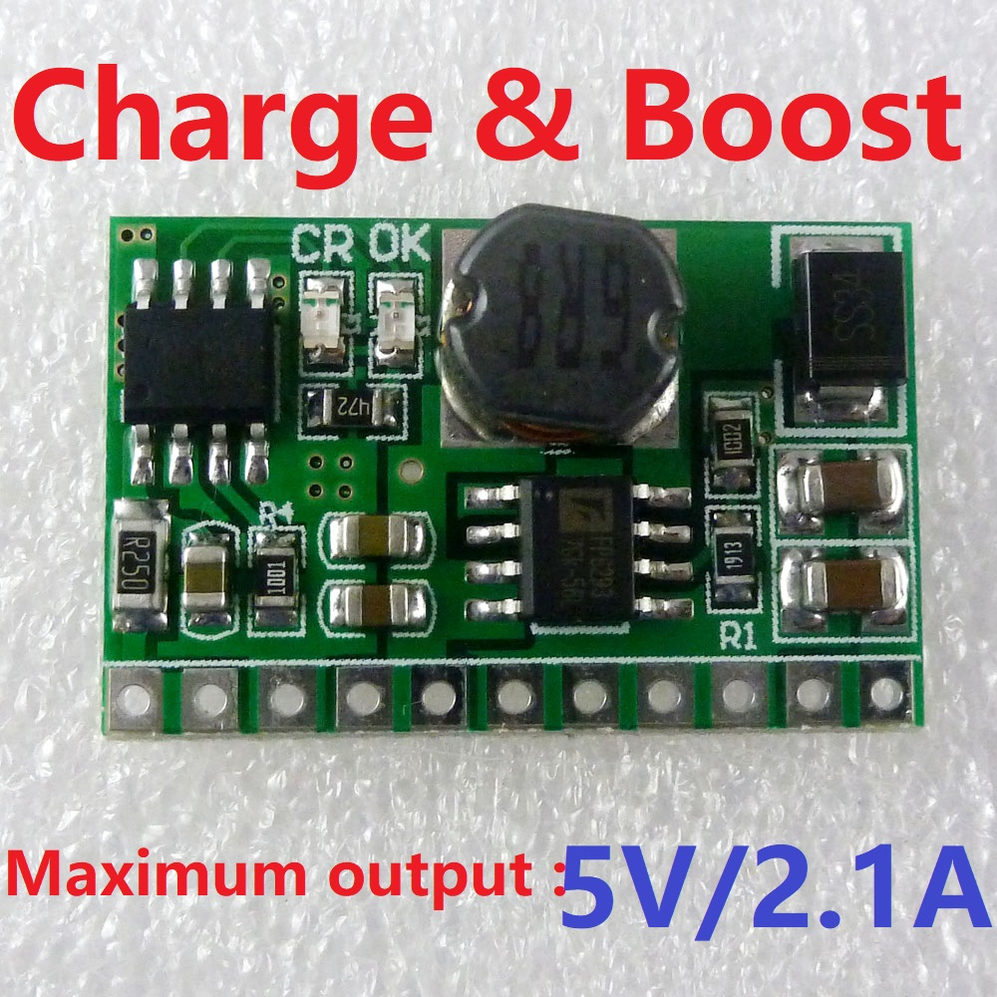

Description:

10W charge and Discharger(boost) modules

Charge voltage : DC 5V ( 4.6V-6.5V )
Charging current : 0-1A
Full charge voltage : 4.2V+-2%.
Led indicator : "OK" LED is fully charged OR battery failure status indicator;
"CR" LED is charge status indicator

Discharge current : 0-3.5A;
Discharge quiescent current : 200uA
Discharge conversion efficiency : 78%-91%

Output current : 0-2.1A(5V);

Operating ambient temperature : -40° to +85°
Storage temperature : -65° to +125°

Size: 28 x 18 x 6.3mm
Weight : 2.7g

Note :
1 This module without lithium battery over-discharge protection,
Matching protection board Click here to buy
2 In order to achieve more than 5W, it is recommended to use two or more batteries in parallel

Applications:
Battery powered equipment
Lithium Battery 18650 14500
Mobile phone diy
Portable charger diy
UPS power supply equipment diy
Solar charging
MP3/MP4 player
Audio equipment
Video equipment
Portable Devices
Bluetooth Wifi Applications
MCU development board

