Product Name: DC 5V 2.1A Mobile Power Diy Board 4.2V Charge/Discharger(boost)/battery protection/indicator module 3.7V lithium 18650 LI-ON
Packing list:

1 PCS DD06CVSA 5V/2.1A Mobile Power Diy Module
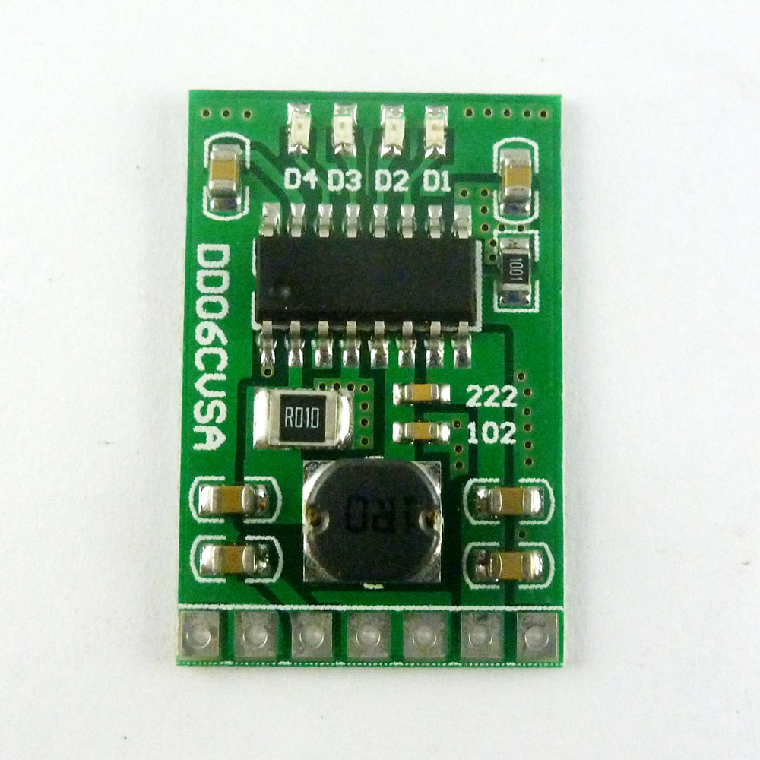

Description:

4 in 1 charge/Discharger(boost)/battery protection/Battery level indicator modules

DD06CVSA is a multifunctional 3.7V/4.2V Mobile Power Diy module,3 in 1 Function: charge,discharge and battery protection.
It is very suitable for DIY mobile power.

Charge voltage : DC 4.5V-5.2V (If the power supply is 5.2V-5.5V, please parallel diodes (eg SS34 SMB))
Charging current : 0-2.1A
Charge quiescent current : 100uA
Full charge voltage : 4.2V+-1%.
Discharge current : 0-3.5A;
Discharge quiescent current : 50uA
Discharge conversion efficiency : maximum 96%
Output voltage : 5V
Output current : 0-2.1A;
Operating ambient temperature : -20° to +85°

Size : 26.7 x 18.1 x 5.7mm
Weight : 1.9g

Comes with battery protection, do not need battery protection board
(if your battery comes with a protective board, it does not matter)
Overcurrent protection(OCP)
Overvoltage protection(OVP)
Short circuit protection(SCP)
Over temperature protection(OTP)

Pin description:
1 VIN : Charging port +
2 GND : Charging port -
3 BAT : Battery port +
4 GND : Battery port -
5 GND : Output port -
6 VOUT: Output port +
7 KEY : Output trigger port(Low pulse trigger)

1 In discharge mode(In the charging mode,the KEY function is invalid),
the KEY Trigger once,turn on the output;Continuous trigger twice: turn off the output.

2 When the load access, it will automatically turn on the output.
But if the load is less than 50MA, the output will be turned off after 30 seconds

NOTE:
If the output load current is less than 50MA, turn off the output after 30 seconds.
If the output load current is greater than 50MA,continuous turn on the output
This module is not suitable for uninterruptible power supply(ups),If you need the UPS module, Click here to buy

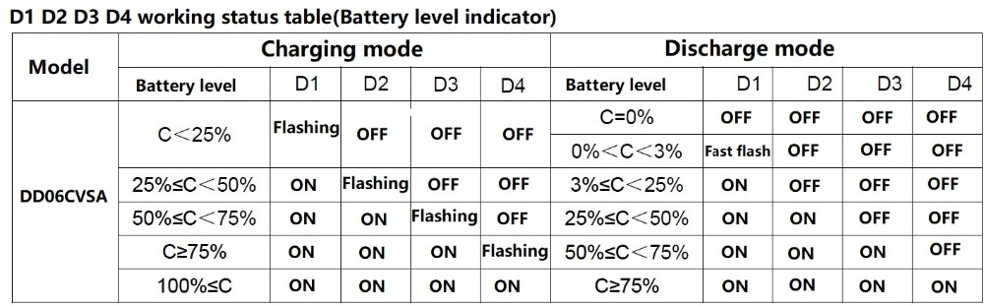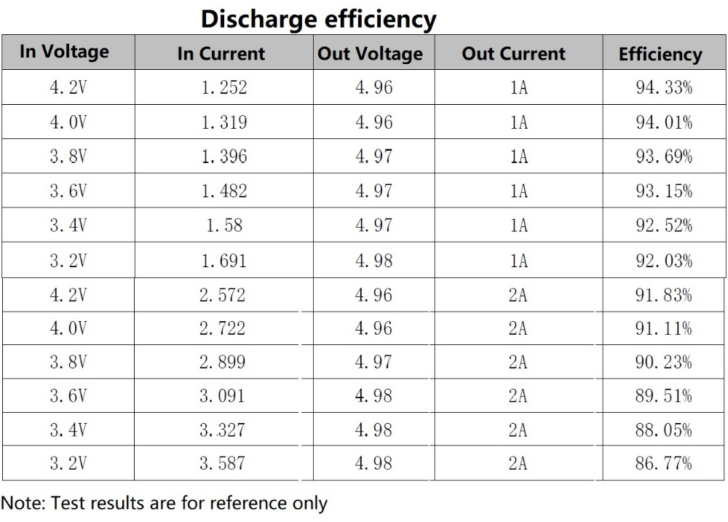

Applications:
Battery powered equipment
Lithium Battery 18650 14500
Mobile phone diy
Solar charging
MP3/MP4 player
Audio equipment
Video equipment
Portable Devices
Bluetooth Wifi Applications
MCU development board

